Validation was done at <https://www.investor.gov/financial-tools-calculators/calculators/compound-interest-calculator>

1. One of the early issues I had with the program was making sure the capital gains tax was not taxing the principal amount. I fixed it by subtracting the starting amount from the total so this insured that only the interest was taxed.

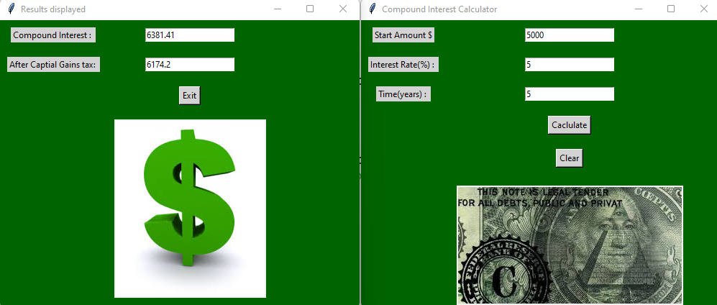

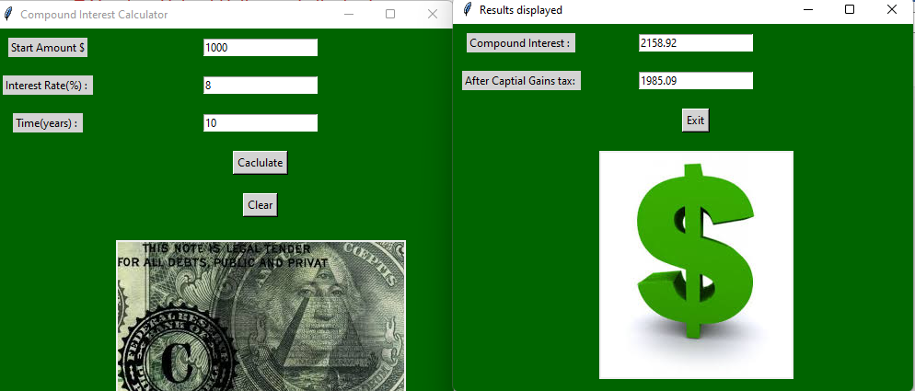

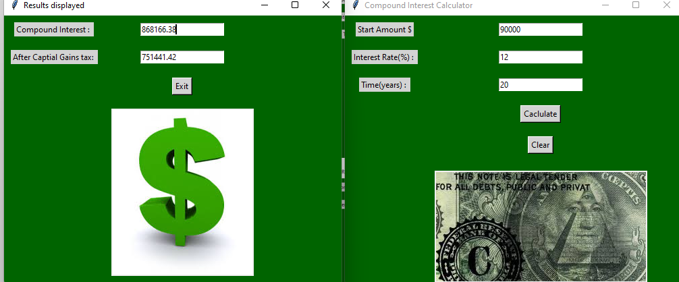

I tested the data against the same data with the [www.investor.gov](http://www.investor.gov) calculator. The data checked out.